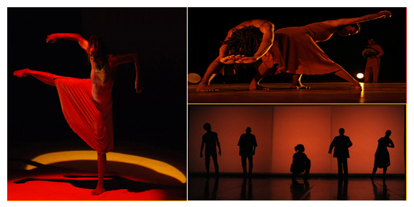

Lénablou
Caribbean Dance Performances and French Lecture
Dance Performance: September 30, Dance Building, 8-9 pm
French Lecture: September 30, Special Collections, 11:15 am-12:05 pm
Impromptu Performance: October 1, Dance Building, 11:15am–12pm
All events are free and open to the public

Lénablou is a renowned choreographer, scholar, and activist known for her innovative promotion of Caribbean performance cultures through her dance technique: the Techni’Ka. Based in the French Caribbean island of Guadeloupe, her dance company TRILOGIE has toured across the world giving performances in Senegal, Niger, Slovenia, Canada, Mexico, Venezuela, French Guiana, Dominican Republic, Trinidad & Tobago, and France and now Athens, GA. She will visit UGA with three of her dancers and two musicians to hold various public events.
The free dance performance of “Fenêtre sur… mon bigidi et moi…” (“Window into My Imbalanced Body”) and “Yonn Dé” (“One Two”) will be held on September 30th at 8 p.m. in the New Dance Theatre, Dance Building (between Soule and Green streets).
Free tickets can be picked up in advance at the UGA Performing Arts Center (pac.uga.edu, 706-542-4400) and the Tate Student Center Cashier's Window. Tickets will also be available at the door beginning at 7:30pm.

Lénablou will lecture in French on the concept of the “bigidi,” a Creole word for the imbalanced body. She will give the talk, “Le concept du bigidi: réponse d’une interculturalité force," on September 30th at 11:15 in the Richard B. Russell Building Special Collections Libraries Auditorium.
The troupe will give an impromptu dance performance, “Shattering the Self,” on October 1st at 11:15 in the New Dance Theatre, Dance Building.

