SPAN 4080 Spanish Modernity From Life as a Dream to Life on Uranus
Prof. Dana Bultman T/TH 9:30-10:45 112 Gilbert SPRING 2020

We will begin by taking a close look at two masterpieces of Spain’s Baroque literary and visual culture, Calderón’s dark philosophical comedy Life is a Dream and Velazquez’s perspective-changing painting Las Meninas. These works place human subjects in worlds that question our sense perceptions and understanding of the truth. Ironically, as artistic products of a decadent empire with a rigid Catholic identity they deeply influenced subsequent modern European representations of reality. How do the features of modernity emerge in Spain and exert influence? Our course will explore concepts of the self, material nature, science, secularization and social movements in textual, performance and visual art from the Enlightenment to the present. We will travel from a 17thcentury world of arcane symbols and disguises, through the dubious light of the Age of Reason, and into the catastrophes of 20thcentury history. Writers and artists include Jesuit moralist Gracián, activist and early feminist Amar de Borbón, romantic author and sketch artist Bécquer, philosopher Ortega y Gasset, and painters Goya and Picasso. Our final work by the contemporary art curator and thinker Paul B. Preciado, An Apartment on Uranus (2019), imagines existence on “another planet,” radically free from the gender and racial systems of high-tech capitalist Europe.
This class has a creative component. Students will be mentored to produce a final piece of creative writing, performance, or cultural event either solo or in collaboration with other class members.

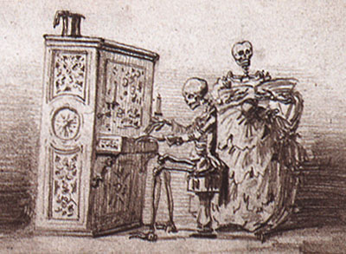
«Concierto de espectros» (1860), dibujo de Gustavo Adolfo Bécquer
Álbum de Julia Espín. Biblioteca Nacional (Madrid).

Textos:
Calderón, La vida es sueño
Gracián, Oráculo manual
Amar y Borbón, Discurso en defensa del talento de las mujeres
Bécquer, Leyendas
Ortega y Gasset, La deshumanización del arte
Preciado, Un apartamento en Urano

